Pre-Lab 1: Wireshark and your local network

## What to submit?

Please use this document as a template, add your responses directly, and export it as a PDF to Gradescope.

## Individual or group?

Lab 1 is done individually. After this lab, we’ll group up.

# 

# A: Install Wireshark

*[ there are no deliverables for this section ]*

# B: Understanding Interfaces

**Q1–HW Variation:**

**a.) Describe briefly the operating system and hardware of your computer:**



**OS – Windows 11- 64 bit.**

**b.) Make a table (or annotate a screenshot) of all the interfaces on your machine.**

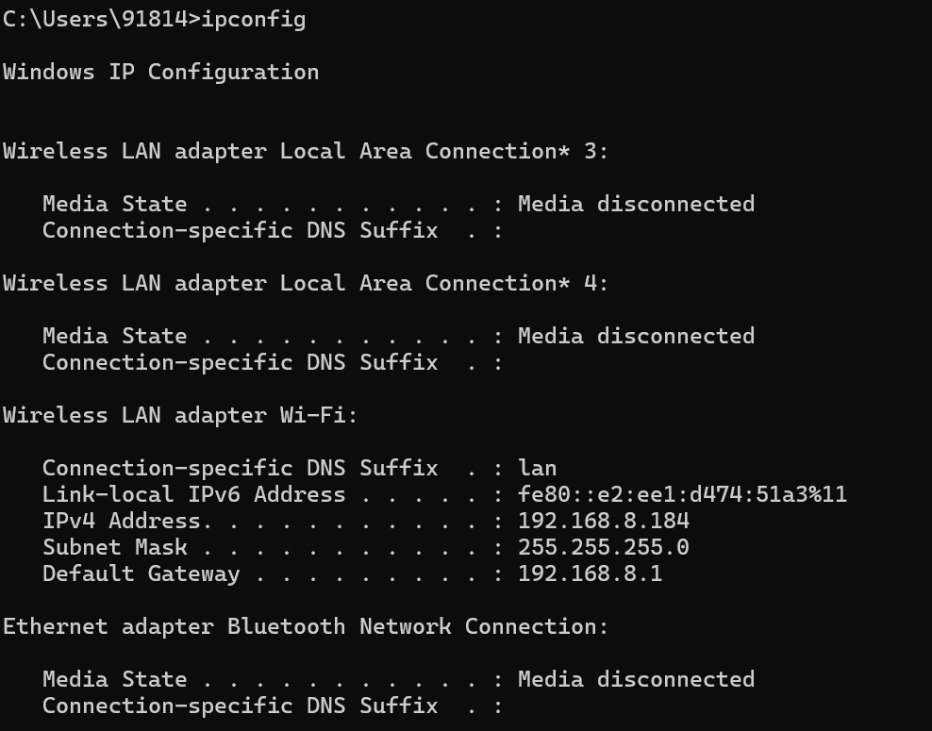

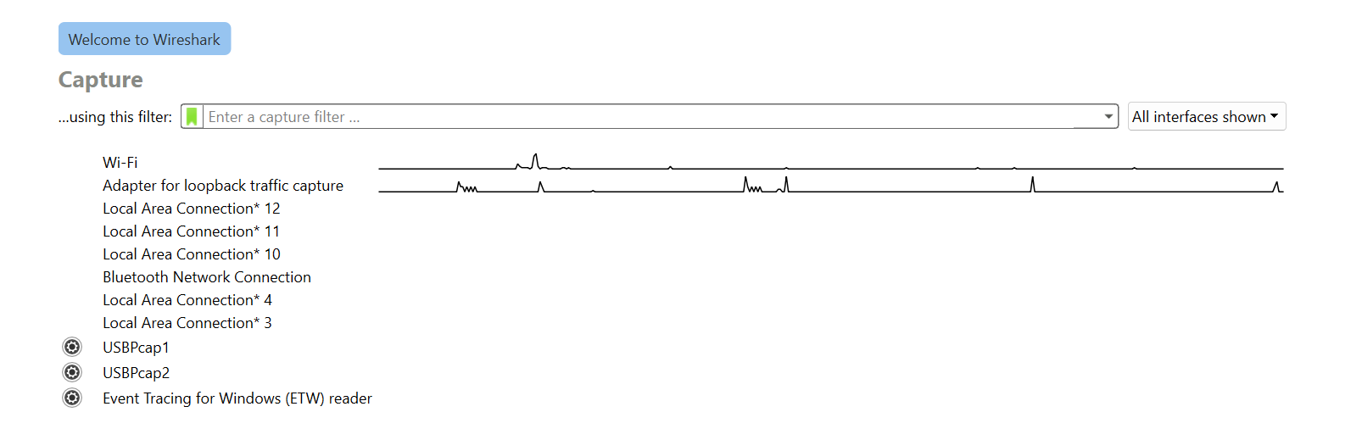

|  | Do you know what this is offhand (don’t look anything up yet)? |
| --- | --- |
| LAN adapter | This allows devices to access the internet or communicate with other devices on the network. |
| Wireless LAN or Wifi | This is wireless LAN, so again used to internet and to connect to other device on network. For example to deived on UCSD Guest network . |
| Ethernet adapter Bluetooth network connection | allows you to connect devices that only have Bluetooth capabilities to a wired Ethernet network, essentially bridging the gap between the two technologies by using a device that can receive an Ethernet signal and then transmit it wirelessly via Bluetooth to other nearby devices; this is useful for situations where you need to connect Bluetooth devices to a stable, high-speed internet connection that is only accessible through an Ethernet cable. |
|  |  |
|  |  |

**Q2–Common Interfaces:**

**Update the table below to identify which interface corresponds to traditional hardware.**

*If you have a slightly different configuration (e.g., multiple ethernet interfaces?), feel free to update the table, but generally you shouldn’t need to add any rows, the question is ‘when folks say WiFi, what interface does that mean on your machine’.*

|  | Which interface is it, how did you know? “I’ve looked into this before” is a fine answer if appropriate, or whatever website you found the info on. |
| --- | --- |
| WiFi | I know this from before, Also just googled it to confirm. |
| Ethernet | I know this from before, Also just googled it to confirm. |

**Q3–Other Interfaces:**

**Pick three other interfaces from the list in Q1(b) that you did not assign a role in Q2. Explain in simple terms what the interface corresponds to.**

*If your machine doesn’t have three additional interfaces, use one of the names from the screenshot in the lab manual of my machine (which is a Mac Pro in that screenshot).*

**i.) VmWare Network Adapter :**  acts as a virtual interface that allows a virtual machine (VM) to connect to a network within a VMware environment, essentially acting as the bridge between the VM's operating system and the physical network by utilizing the host machine's network connection; it's a key component for enabling network connectivity for virtual machines running on a VMware platform.

**ii.) Adapter for Loopback Traffic Capture : To capture the loopback the traffic from the computer. Its generally used for debugging.**

**iii.)**